Practical-14:

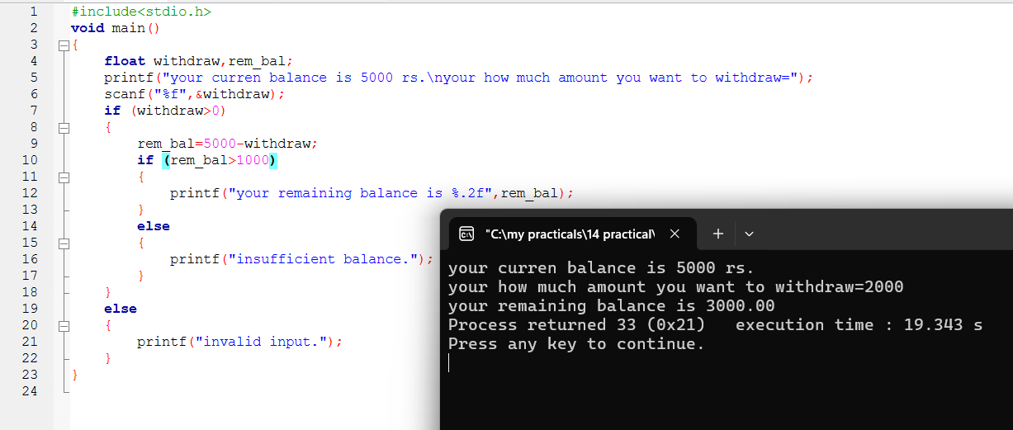

14-i: 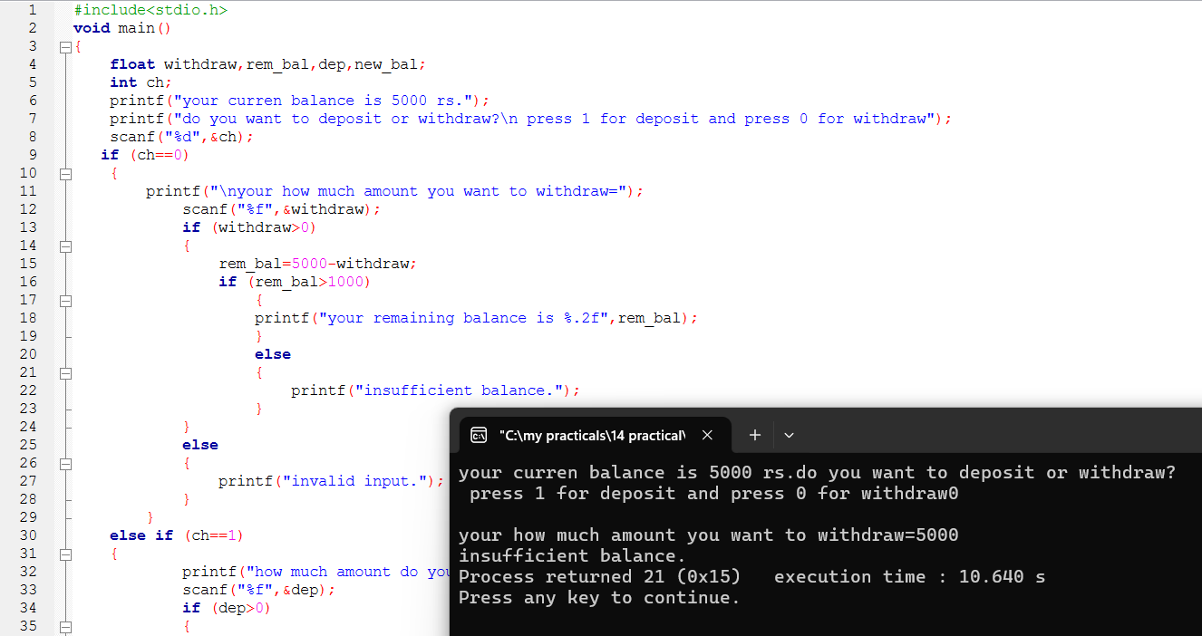

14-ii:

